Institute of Computer Technology

B. Tech Computer Science and Engineering

Sub: Database Management System (2CSE301)

Practical 3: **Performing queries with various operators and functions.**

Scenario : Mohan was worried about total income to getting raised every month for which he has to query differently in sales table. Thus he suggested IT Company to have multiple options to see the count of sales happen every day or weekly or monthly.

**COMPUTATION ON TABLE DATA**

None of the techniques used till now allows displays of some data from a table after some arithmetic has been done with it.

Arithmetic and logical operators give a new dimension to SQL sentences.

**Arithmetic Operators:**

Oracle allows arithmetic operator to be used while viewing records from a table or while performing Data Manipulation operations such as Insert, Update and Delete.

+ Addition * Multiplication

- Subtraction ** Exponentiation / Division ( ) Enclosed operation

For example:

Retrieve the content of the column p_no, description and compute 5% of the values contained in the column sell_price for each row from the table product_master.

Sql>**SELECT** p_no, description, sell_price*0.05

**FROM** product_master;

**Renaming Columns used with Expression Lists:**

When displaying the result of a query, SQL *PLUS normally uses the selected column's name as the column heading.

These column names may however be short and cryptic; they can be changed for better understanding of the query result by entering an alias, or substitute name, after the column name in the select clause.

Sql>**SELECT** columnname result_columnname, columnname result_columnname

**FROM** table name For example:

Retrieve the content of the column p_no, description and compute 5% of the values contained in the column sell_price for each row from the table product_master. Rename sell_price * 0.05 as **Increase.**

Sql>**SELECT** p_no, description, sell_price*0.05 Increase

**FROM** product_master;

**Logical Operators:**

Logical operators that can be used in SQL sentence are:

1. **AND operator:**

The Oracle engine will process all rows in a table and display the result only when all of the conditions specified using the AND operator are satisfied.

sql **>SELECT** column list

**FROM** tablename

**WHERE** columnname **AND** columnname;

Sql>**SELECT** p_no, desc, p_percent

**FROM** product_master

**WHERE** p_percent>=10 **AND** p_percent<=20;

1. **OR operator:**

The Oracle engine will process all rows in a table and display the result only when any of the conditions specified using the OR operators are satisfied.

sql **>SELECT** column list

**FROM** tablename

**WHERE** columnname **OR** columnname;

sql **>SELECT** c_no, name, address, pincode

**FROM** client_master

**WHERE** (pincode=400125 **OR** pincode=400126);

1. **NOT operator:**

The Oracle engine will process all rows in a table and display the result only when none of the conditions specified using the NOT operator are satisfied.

Sql> **SELECT** c_no, name, address, pincode

**FROM** client_master **WHERE NOT** (city=’Bombay’ or city=’Delhi’);

**Range Searching:**

In order to select data that is within a range of values, the **BETWEEN** operator is used. This operator allows the selection of rows that contain values within a specified lower and upper limit.

sql **>SELECT** column list from tablename

**WHERE** column **BETWEEN** min _value **AND** max_value;

sql **>SELECT** c_no, name, address, pincode

**FROM** client_master

**WHERE** bal_due  **BETWEEN** 100  **AND** 500;

**Note:**

.BETWEEN is an inclusive operator i.e. if either the min value or the max value is found, as well as any in between, the row is returned.

**4. NOT BETWEEN**

Rows not having value in the range specified, and also not having value equal; to min or the max value is returned.

sql **>SELECT** column list from tablename

**WHERE** column **NOT BETWEEN** min _value **AND** max_value;sql **>SELECT** c_no, name, address, pincode

**FROM** client_master

**WHERE** bal_due **NOT**  **BETWEEN** 100  **AND** 500;

**Pattern Matching:**

1. **LIKE**

Allows comparison of one string value with another string value, which is not identical. This is achieved by using wildcard characters. Two wildcard characters that are available are:

* + The percent sign **(%)** that matches any string.
  + The Underscore **( _ )** that matches any single character.

sql >**SELECT** column list **FROM** tablename

**WHERE** column **LIKE** 'pattern';

OR

**WHERE column NOT LIKE' pattern';** For example:

Retrieve all information about suppliers whose name begin with the letter ‘ja’ fro supplier_master.

sql >**SELECT * FROM** supplier_master

**WHERE** s_name **LIKE ‘**ja%’;

1. **IN**

This operator can be used to select rows that match one of the values included in the list.

sql>**SELECT** columnlist **FROM** tablename

**WHERE** columnlist **IN (**list of values);

For example:

Retrieve the details from supplier table where supplier name is either Aman or Vimal or Ajay.

sql>**SELECT** s_no, name, city, address, pincode

**FROM** supplier_master

**WHERE** name **IN** (‘Aman’, ‘Vimal’, ‘ Ajay’ );

1. **NOT IN**

The **NOT IN** predicate is the opposite of the IN predicate. This will select all the rows where values do not match all of the values in the list.

sql>**SELECT** columnlist **FROM** tablename

**WHERE** columnlist **NOT IN (**list of values);

1. **IS NULL**

This operator is used to compare the value in the column with NULL and returnthe row accordingly.

sql >**SELECT** column list **FROM** tablename

**WHERE** columnis **NULL;**

OR

**WHERE** columnis not **NULL;**

**ORACLE FUNCTIONS:**

Oracle functions serve the purpose of manipulating data items and returning result. Functions are also capable of accepting user-supplied variables or constants and operating on them. Such variables or constants are called as argument. Any number of arguments can be passed to a function in the following format:

**Function_name (argument1, argument2, …).**

Oracle functions can be clubbed together depending upon whether they operate on a single row or a group of rows retrived from a table. Accordingly, functions can be classified as follows:

**Group Functions (Aggregate Function):**

Functions that act on a set of values are called as group functions. For example, SUM, is a function which calculates the total of a set of numbers. A group function returns a single result row a group of queried rows.

**Scalar Function (Single Row Function):**

Functions that act on only one value at a time are called as scalar functions. For example, LENGTH, is a function, which calculates the length of one particular string value. A single row function returns one result for every row of a queried table or view.

Single row function can be further grouped together by the data type of their arguments and return values. For example, LENGTH, relates to the string Data type. Functions can be classified corresponding to different data types as:

String functions : Work for String Data type

Numeric functions : Work for Number Data type

Conversion functions : Work for Conversion of one type to another. Date functions : Work for Date Data type

**Aggregate Functions:**

|  |  |  |
| --- | --- | --- |
| **AVG** | Syntax | AVG([DISTINCT|ALL]n) |
| Purpose | Return average value of n ignoring null values. |
| Example | Select AVG(sell_price) “Average” from p_master; |
| Output | Average  2012.3654 |
| **MIN** | Syntax | MIN([DISTINCT|ALL]expr) |
| Purpose | Return minimum value of ‘expr’. |
| Example | Select MIN(bal_due) “Min_bal” from c_master; |
| Output | Min_bal  0 |
| **COUNT** | Syntax | MIN([DISTINCT|ALL]expr) |
| Purpose | Return the number of rows WHERE ‘expr’ is not null . |
| Example | Select COUNT(p_no) “Products” from P_master; |
| Output | Products  9 |
| **COUNT(*)** | Syntax | COUNT(*) |
| Purpose | Return the number of rows in the table, including duplicates and those with nulls.. |
| Example | Select COUNT(*) “Total” from C_master; |
| Output | Total  9 |
| **MAX** | Syntax | MAX([DISTINCT|ALL]expr) |
| Purpose | Return maximum value of ‘expr’. |
| Example | Select MAX(bal_due) “Maximum” from c_master; |
| Output | Maximum  15000 |
| **SUM** | Syntax | SUM([DISTINCT|ALL]n) |
| Purpose | Return Sum of values of ‘n’. |
| Example | Select SUM(bal_due) “Balance” from c_master; |
| Output | Balance  22000 |

**Numeric Functions:**

|  |  |  |
| --- | --- | --- |
| **ABS** | Syntax | ABS(n) |
| Purpose | Return the absolute values of ‘n’. |
| Example | Select ABS(-15) “Absolute” from dual; |
| Output | Absolute  15 |
| **POWER** | Syntax | POWER(m,n) |
| Purpose | Returns m raised to nth power. N must be an integer, else an error is returned. |
| Example | Select POWER(3,2) “Raised” from dual; |
| Output | Raised  9 |
| **ROUND** | Syntax | ABS(n[,M]) |
| Purpose | Returns ‘n’ rounded to ‘m’ places right the decimal point. If ‘m’ is omitted ‘n’ is rounded to 0 places. ‘m’ can be negative to round off digit left of the decimal point ‘m’ must be an integer. |
| Example | Select ROUND(15.19,1) “Round” from dual; |
| Output | Round  15.2 |
| **SQRT** | Syntax | SQRT(n) |
|  | Purpose | Returns square root of ‘n’. if n<0, NULL. SQRT returns a real result. |
| Example | Select SQRT(25) “Square root” from dual; |
| Output | Square root  5 |

**String Functions:**

|  |  |  |
| --- | --- | --- |
| **LOWER** | Syntax | LOWER(char) |
| Purpose | Return char, with all letters in lowercase. |
| Example | Select LOWER(‘XYZ’) “Lower” from dual; |
| Output | Lower  xyz |
| **INITCAP** | Syntax | INITCAP(char) |
| Purpose | Return STRING with first letter in upper case. |
| Example | Select INITCAP(‘COMP DEPT’) “Title Case” from  dual; |
| Output | Title Case  Comp Dept |
| **UPPER** | Syntax | UPPER(char) |
| Purpose | Return char, with all letters in uppercase. |
| Example | Select UPPER(‘xyz’) “Upper” from dual; |
| Output | Upper  XYZ |
| **SUBSTR** | Syntax | UPPER(char, M[,n]) |
| Purpose | Return a portion of char, beginning at character ‘m’ exceeding up to ‘n’ characters. If ‘n’ is omitted, result is returned up to the end char. The first position of char is 1. |
| Example | Select SUBSTR(‘SECURE’,3,4) “Substring” from dual; |
| Output | Substring  CURE |
| **LENGTH** | Syntax | LENGTH(char) |
| Purpose | Return the length of character. |
| Example | Select LENGTH(‘xyz’) “Length” from dual; |
| Output | Length  3 |
| **LTRIM** | Syntax | LTRIM(char[,Set]) |
| Purpose | Return characters from the left of char with initial. |
| Example | Select LTRIM(‘College’,’C’) “Left” from dual; |
| Output | Left  ollege |
|  |  |  |
| **RTRIM** | Syntax | RTRIM(char[,Set]) |
| Purpose | Return char, with final characters removed after the last character not I the set. ‘set’ is optional, it defaults to spaces. |
| Example | Select RTRIM(‘College’,’e’) “Right” from dual; |
| Output | Right  Colleg |
| **LPAD** | Syntax | LPAD(char1,n,[,char2]) |
| Purpose | Return ‘char1’, left padded to length ‘n’ with the sequence of characters in ‘char2’, ‘char2, defaults to blanks. |
| Example | Select LPAD(‘Page 1’,10,’*’) “Lpad” from dual; |
| Output | Lpad  ****Page 1 |
| **RPAD** | Syntax | RPAD(char1,n,[,char2]) |
| Purpose | Return ‘char1’, right- padded to length ‘n’ with the characters in ‘char2’, replicated as many times as necessary. If ‘char2’ is omitted, right-pad is with blanks. |
| Example | Select RPAD(‘page’,10,’x’) “Rpad” from dual; |
| Output | Rpad  Pagexxxxxx |

**Conversion Functions:**

|  |  |  |
| --- | --- | --- |
| **TO_NUMBER** | Syntax | TO_NUMBER(char) |
| Purpose | Converts ‘char’ , a character value containing a number to a value of number datatype. |
| Example | Update P_master set sell_price= sell_price +  TO_NUMBER(SUBSTR(‘$100’,2,3));    Here the value 100 will be added to every products selling price in the product_master table. |
| **TO_CHAR** | Syntax | TO_CHAR(n[,fmt]) |
| Purpose | Converts a value of number data type to a value of char data type, using the optional format string. It accepts a number (n) and a numeric format (fmt) in which the number has to appear. If ‘fmt’ is omitted,  ‘n’ is converted to a char value exactly long enough to hold significant digits. |
| Example | Select TO_CHAR(17145,’$099,999’)”char” from dual; |
| Output | Char  $017,145 |
| **TO_CHAR** | Syntax | TO_CHAR(date[,fmt]) |
| Purpose | Converts a value of DATE data type to a value of char data type, using the optional format string. It accepts a date (date), as well as format (fmt) in which the date has to appear. ‘fmt’ must be a date format.. If ‘fmt’ is omitted, ‘date’ is converted to a char value in the default date format, i.e. “DD-MON-YY”. |
| Example | Select TO_CHAR(O_DATE,’Month DD, YYYY) “Format” from s_order where o_no=’o42541’; |
| Output | Format  January 26, 20006 |

**Date Conversion Functions:**

|  |  |  |
| --- | --- | --- |
| **TO_DATE** | Syntax | TO_DATE(char [,fmt]) |
| Purpose | Converts a character field to a date field. |
|  |  |
| **ADD_MONTHS** | Syntax | ADD_MONTHS(D,N) |
| Purpose | Returns date after adding the number of months specified with the function |
| Example | Select ADD_MONTHS(SYSDATE, 4) from dual; |
| Output | ADD_MONTHS  04-AUG-06 |
|  |  |
| **LAST_DAY** | Syntax | LAST_DAY(d) |
| Purpose | Returns the last date of the month specified with the function. |
| Example | Select  SYSDATE,LAST_DAY(SYSDATE)”Last” from dual; |
| Output | SYSDATE Last  04-AUG-06 31-AUG-06 |
|  |  |
| **MONTHS_BETWEEN** | Syntax | MONTHS_BETWEEN(d1,d2) |
| Purpose | Returns number of months between d1 and d2. |
| Example | Select MONTHS_BETWEEN(’04-AUG-06’, ‘04-JUL-06’ )”Month” from dual; |
| Output | Month  1 |
|  |  |
| **NEXT_DAY** | Syntax | NEXT_DAY(date,char) |
| Purpose | Returns the date of the first weekday named by  ‘char’ that is after the date named by ‘date’.  ‘Char’ must be a day of the week. |
| Example | select NEXT_DAY(’04-feb-06’, ‘Friday’) “Next day” from dual; |
| Output | Next day 06-feb-06 |

**The Oracle Table ‘DUAL’:**

Dual is a small Oracle worktable, which consists of only one row and and one column, and contains the value x in that column. Besides arithmetic calculation, it also supports date retrieval and it’s formatting.

When an arithmetic exercise is to be performed such as 2*2 or 4/3 etc., there really is no table being referenced; only numeric literals are being used.

To facilitate such calculation via a SELECT, Oracle provides a dummy table called DUAL, against which SELECT statements that are required to manipulate numeric literals can be fired, and output obtained.

Sql>**SELECT** 2*2 **FROM** DUAL;

Output:

2*2

__________

4

**SYSDATE:**

Sysdate is a pseudo column that contains the current date and time. It requires no arguments when selected from the table DUAL and returns the current date.

Sql>**SELECT** sysdate **FROM** DUAL;

Output:

Sysdate

____________

06-jun-06

**Exercise:**

Create table sales_order and insert data as given below.

|  |  |  |
| --- | --- | --- |
| **Column Name** | **Data Type** | **Size** |
| Order_no | Varchar | 6 |
| Order_date | Date |  |
| Client_no | Varchar | 6 |
| S_no | Varchar | 6 |
| Dely_type | Char | 1 |
| Billed_yn | Char | 1 |
| Dely_date | Date |  |
| Order_status | Varchar | 10 |

|  |  |  |  |  |  |  |  |
| --- | --- | --- | --- | --- | --- | --- | --- |
| Order_no | Order_date | Client_no | S_no | Dely_ type | Billed_yn | Dely_date | Order_status |
| O1901 | 06/12/2015 | C001 | S001 | F | N | 06/20/2015 | InProcess |
| O1902 | 01/25/2015 | C002 | S002 | P | N | 06/27/2015 | Cancelled |
| O4665 | 02/18/2015 | C003 | S003 | F | Y | 02/20/2015 | Fullfilled |
| O1903 | 04/03/2015 | C001 | S001 | F | Y | 04/07/2015 | Fullfilled |
| O4666 | 05/20/2015 | C004 | S002 | P | N | 05/22/2015 | Cancelled |
| O1908 | 05/24/2015 | C005 | S003 | F | N | 05/26/2015 | InProcess |

Solve the following queries using the database given in practical 1 and above table.

**Queries on computation on table data:**

1. Find the name of all clients having ‘a ‘ as the second letter in their names

select * from client_master where name like '_a%';

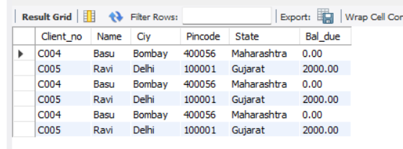

1. Find out the clients whose name is four character ling and second letter is ‘a‘.

select * from client_master where name like '_a%'and length(name)=4;

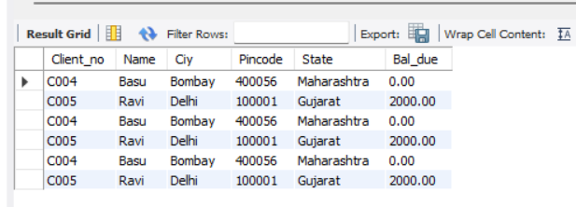

1. Find out the name of city whose second last character is ‘a’.

select * from client_master where City like '%a_';

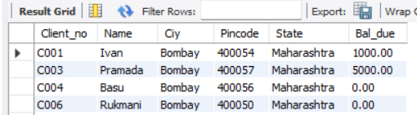

1. Print the list of clients whose bal_due is greater than or equal to 10000.

select * from client_master where Bal_due>=10000;

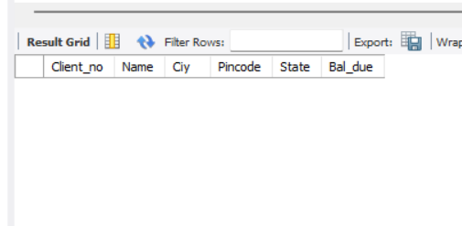

1. Print the information from sales_order table for orders placed in the month of January.

select * from Sales_order where month(Order_date)=01;

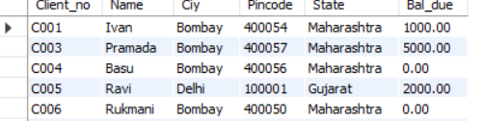

1. Display the order information for client_no ‘C003’ and ‘C001’.

select * from client_master where Client_no='C003' OR Client_no='C001';

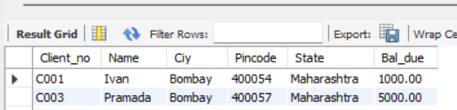

1. Find products whose selling price is greater than 2000 and less than or equal to 5000.

select description,sell_price, sell_price*0.15 as new_price from product_master where Sell_price>2000 AND Sell_price<+5000;

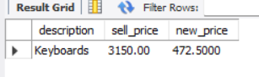

1. Find products whose selling price is more than 1500. Calculate a new selling price as, original selling price * .15. Rename the new column in the above query as new_price.

select description, sell_price, sell_price * 0.15 as new_price from product_master where Sell_price>5000;

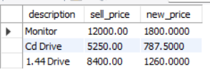

1. List the names, city and state of clients who are not in the state of ‘Maharashtra’.

select * from client_master where not State='Maharashtra';

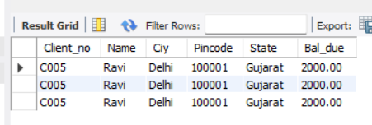

1. Count the total number of orders.

select count(Order_no) from sales_order;

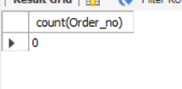

1. Calculate the average price of all products.

select avg(sell_price),avg(Cost_price) from product_master;

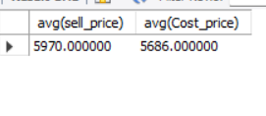

1. Determine the maximum and minimum product prices. Rename the output as max_price and min_price respectively.

select max(sell_price),min(sell_price),max(sell_price) as max_price,min(sell_price) as min_price from product_master;

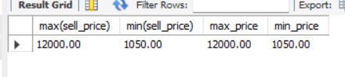

1. Count the number of products having price greater than or equal to 1500.

select count(Product_no) from product_master where Sell_price>=1500;

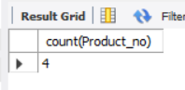

1. Find all the products whose qty_on_hand is less than reorder level.

select * from product_master where Qty_on_hand < Reorder_lvl;

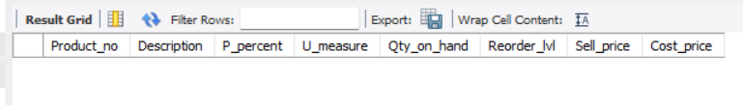

1. Create table cmaster from client_master table.

create table cmaster like client_master;

truncate cmaster;

drop table cmaster;

create table cmaster select * from client_master where City='bombay';

select * from cmaster;

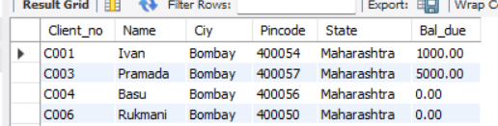

1. Insert data in cmaster from client_master where city=’bombay’

create table cmaster like client_master;

truncate cmaster;

drop table cmaster;

create table cmaster select * from client_master where City='bombay';

select * from cmaster;



1. Create table sales from sales_order with order_no and client_no columns.

create table sales as select order_no,client_no from sales_order;

select * from sales;

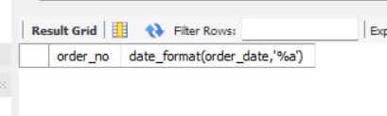

1. Insert data in sales from sales_order table.

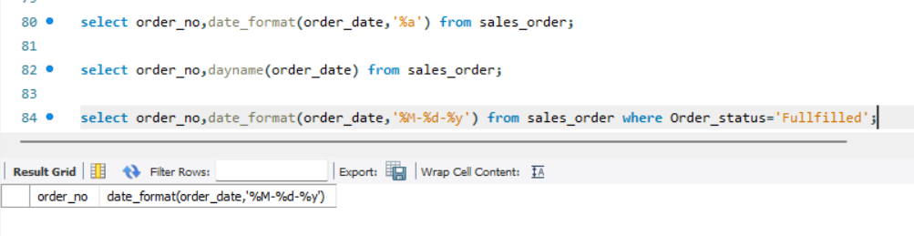

**Queries on Date manipulation:**

1. Display the order number and day on which clients placed their order.

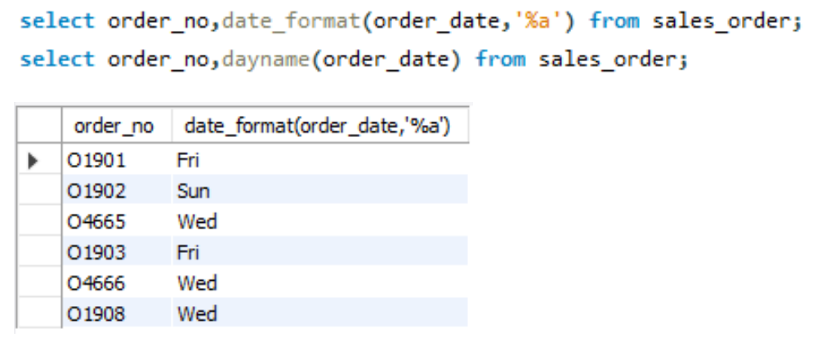

1. Display the month (in alphabets) and date when the order must be delivered.
2. Find the number of days elapsed between delivery date and order date from sales_order table.

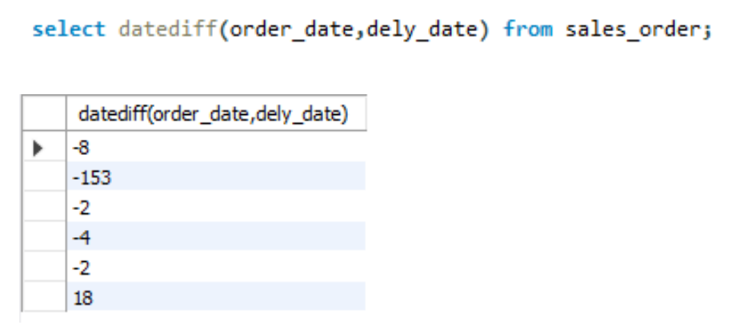

1. Find the date, 15 days after today’s date.

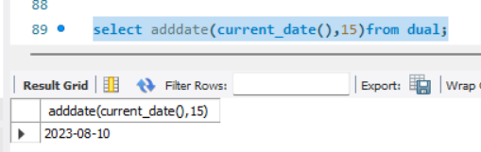

1. Display current date and time.

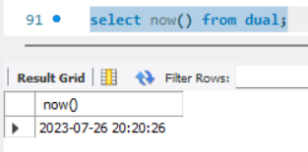

6) Display system time.

